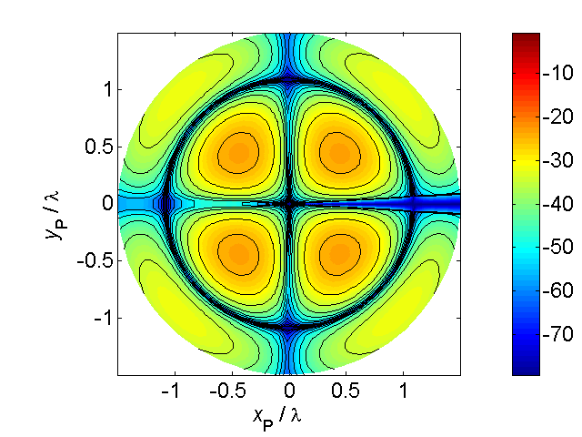

[**HSC PHYSICS ONLINE**](http://www.physics.usyd.edu.au/teach_res/hsp/sp/spHome.htm)

**THERMODYNAMICS**

**METHODS OF HEAT TRANSFER**

**RADIATION**

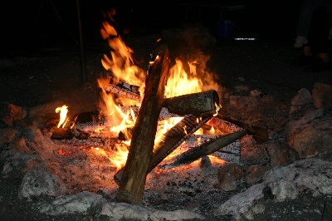**Radiation** is the energy transferred by electromagnetic waves mainly infrared (IR), visible and ultraviolet (UV). All materials radiate energy in the form of electromagnetic waves in amounts determined by their temperature.

Thermal radiation wavelength ranges

micrometre 1 m = 1x10-6 m

nanometre 1 nm = 1x10-9 m



**IR**  ~ 100 - 0. 8 m

**Visible** ~ 0.8 - 0.4 m 800 – 400 nm

**UV** ~0.4 - 0.1 m

All objects above **absolute zero** emit radiant energy and the rate of emission increases and the peak wavelength decreases as the temperature of object increases.

Infrared thermography, thermal imaging, and thermal video are examples of infrared imaging science. Thermographic cameras usually detect radiation in the long-infrared range of the electromagnetic spectrum (9–14 µm or 9000–14000 nm) and produce images of that radiation, called **thermograms**.

Since infrared radiation is emitted by all objects with a temperature above absolute zero according to the **blackbody radiation law**, thermography makes it possible to see one's environment with or without visible illumination. The amount of radiation emitted by an object increases with temperature; therefore, thermography allows one to see variations in temperature. When viewed through a thermal imaging camera, warm objects stand out well against cooler backgrounds; humans and other warm-blooded animals become easily visible against the environment, day or night. Thus, thermography is particularly useful to the military and other users of surveillance cameras.

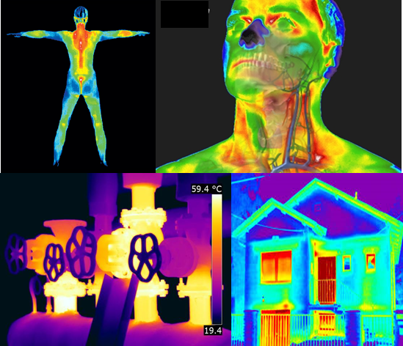

**Electromagnetic Spectrum**

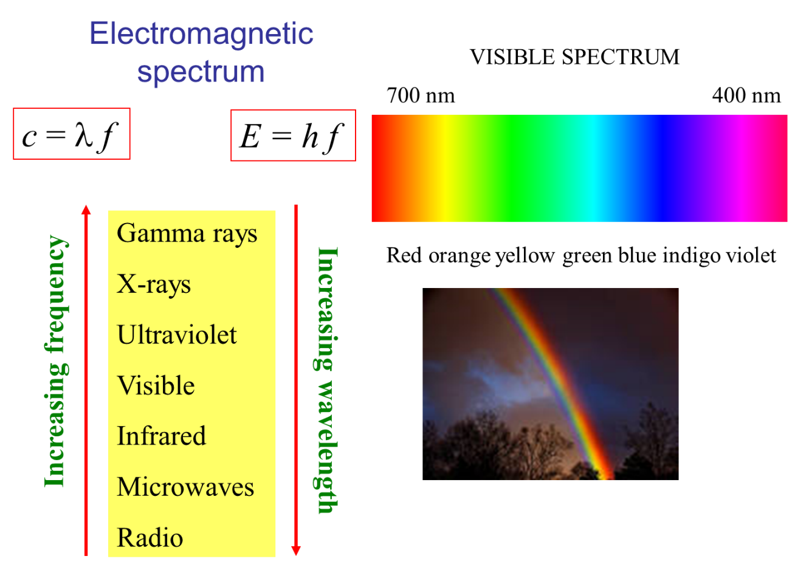

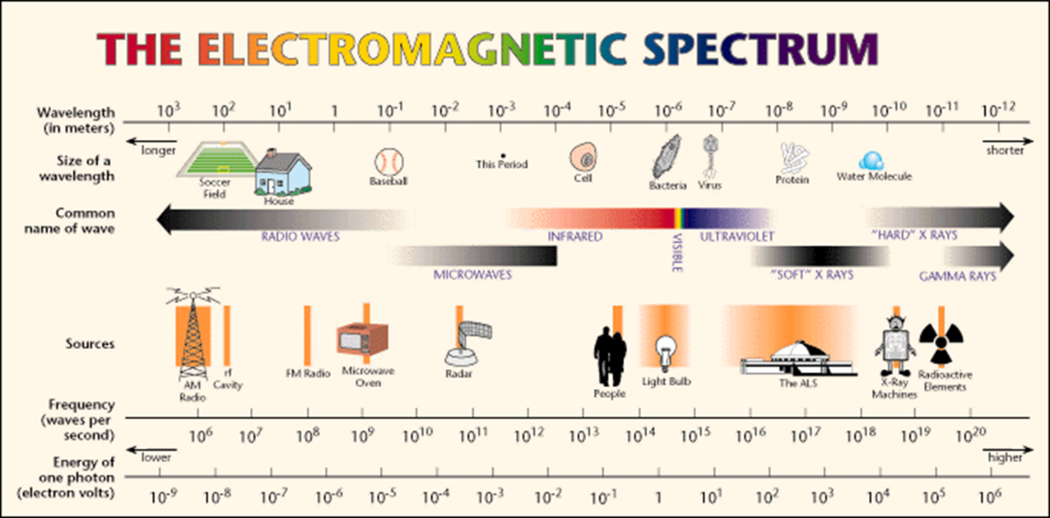

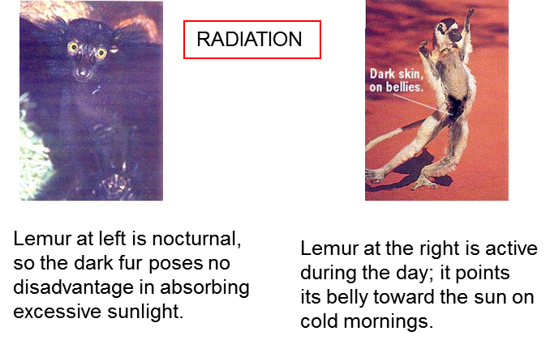

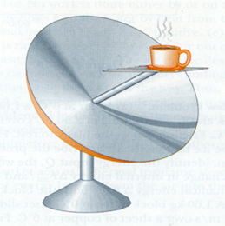

Solar collector

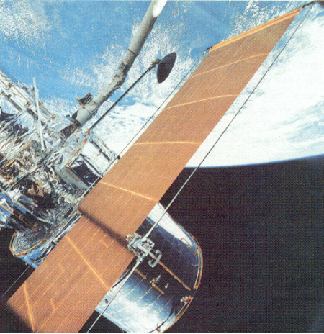

Highly reflecting metal foil keeps inside temperature low

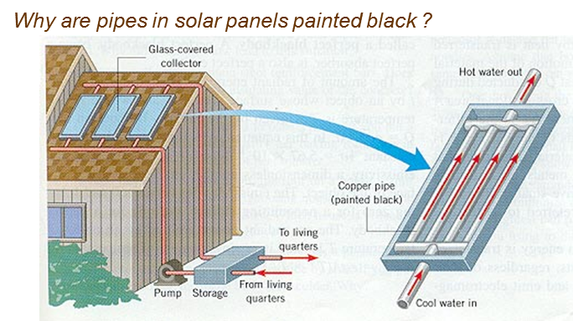

The temperature of the surface of a star can be determined from its colour.

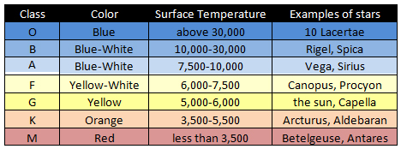

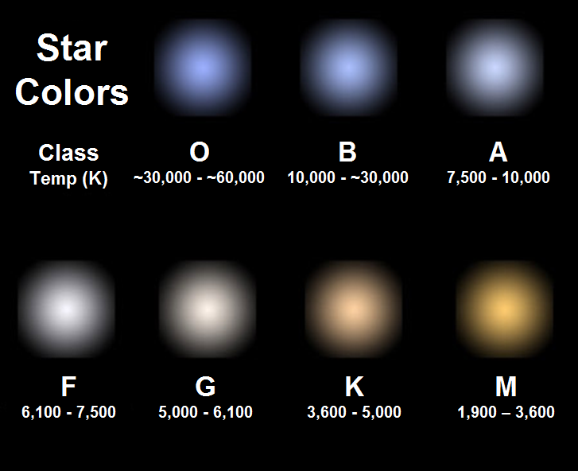

**Radiation Laws**

The Syllabus does not give any equations for the transfer of heat by radiation. So, you don’t need to know the following mathematics, but without this knowledge, you would have a very limited view of fundamental and important ideas related to thermal phenomena.

Every object because of its temperature emits electromagnetic waves. The emission from the surface of an object depends upon the surface area  over which the radiation occurs, the nature of the surface described by the surface emissivity  and the temperature  of the surface. The power (energy / time) radiated  is described by the **Stefan-Boltzmann Law**

 temperature must be in kelvin K

The constant is known as the **Stefan-Boltzmann constant**



Note that the power radiated is proportional to the **fourth** power of the temperature – a small change in temperature leads to a much larger change in the power radiated.

The nature of the surface described by the surface emissivity  which is a dimensionless number between 0 and 1 that indicates how effective the surface is in radiating energy (or absorbing energy). A value of  is a perfect radiator and the object radiating is called a **blackbody**. Generally, a dark- coloured surface has an emissivity near 1, whereas a light- coloured surface has an emissivity must less than 1.

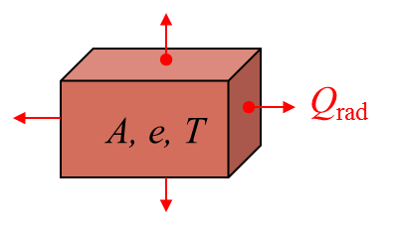

Radiation falling on a surface absorbs that radiation. Therefore, all surfaces are emitting radiation and absorbing it. Thus, if the temperature of a System is  and its surrounding temperature is  the net power  radiated by the object is



If the surface temperature is greater than the surroundings , it radiates more energy that it absorbs, hence, .

If the surface temperature is less than the surroundings , it radiates less energy that it absorbs, hence, .

At equilibrium, where the surface and surroundings are at the same temperature, hence, .

A **blackbody**  is both a perfect radiator and absorber of electromagnetic radiation.

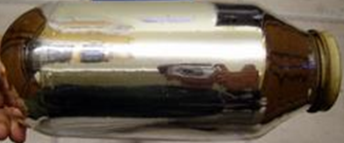

The opposite of a blackbody is an **ideal reflector**, which absorbs zero radiation. This is why the inside of a Thermos bottle is highly reflective, very little heat energy is absorbed from the hot contents.

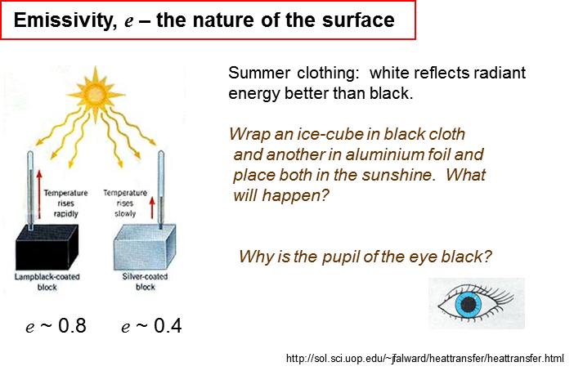

***Thinking question***

Explain the role of the surface of the thermal collector.

To make a solar collector efficient, materials are designed to have a selective surface for the absorption and emission of radiation. The selective surfaces are good absorbers of shortwave radiation (sunlight) and good emitters at longer wavelengths to heat water.

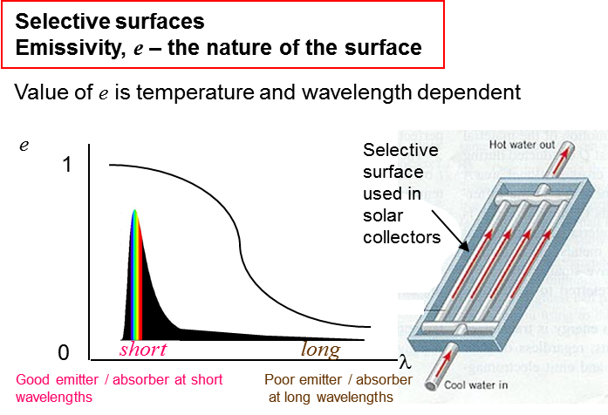

**Wien’s Displacement Law**

A useful law for understanding the radiation emitted from a hot object is **Wien's Displacement Law**. It states that peak wavelength of the radiation emitted from a hot body is inversely proportional to the temperature .

 Wien’s constant 

An interesting graph for the radiation emitted by a blackbody is known as the **blackbody radiation curve** in which the energy radiated is plotted against the wavelength.

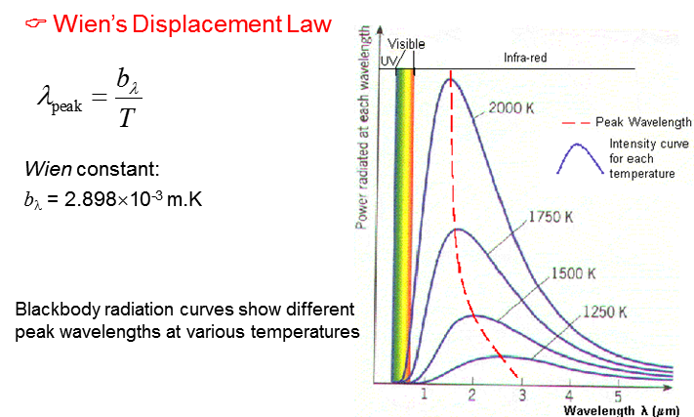

The Sun to a good approximation radiates as a blackbody and its blackbody radiation curve is

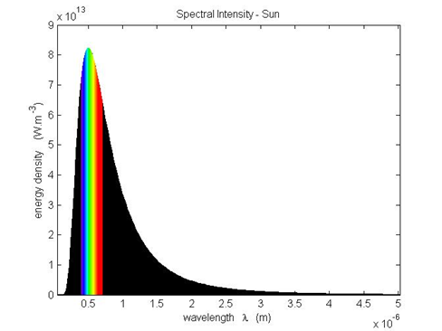

The peak wavelength for the radiation from the Sun is about

 **green ligh**t

From Wien’s Displacement Law, the surface temperature of the Sun is



